***#Assignment A7-SQL#***

**Problem Statement:** Database Trigger (All Types: Row level and Statement level triggers, Before and After Triggers).

Write a database trigger on Library table. The System should keep track of the records that are being updated or deleted. The old value of updated or deleted records should be added in Library_Audit table.

**Source Code:**

CREATE TABLE Borrower_s (

BorrowerID NUMBER PRIMARY KEY,

BorrowerName VARCHAR2(100) NOT NULL,

IssueDate DATE NOT NULL,

BookTitle VARCHAR2(100) NOT NULL,

BookStatus VARCHAR2(1) CHECK (BookStatus IN ('I', 'R')) -- I for Issued, R for Returned

);

SELECT * FROM BORROWER_S;

DROP TABLE LIBRARY_AUDIT_S;

CREATE TABLE library_audit_s (

rollin INT,

name CHAR(25),

dateofissue DATE,

nameofbook CHAR(25),

status CHAR(1),

ts TIMESTAMP

);

SELECT * FROM LIBRARY_AUDIT_S;

CREATE OR REPLACE TRIGGER trg_after_update_borrower

AFTER UPDATE ON Borrower_s

FOR EACH ROW

BEGIN

INSERT INTO library_audit_s (rollin, name, dateofissue, nameofbook, status, ts)

VALUES (

:OLD.BorrowerID,

:OLD.BorrowerName,

:OLD.IssueDate,

:OLD.BookTitle,

:OLD.BookStatus,

SYSTIMESTAMP

);

END;

/

UPDATE Borrower_s

SET BookStatus = 'I'

WHERE BorrowerID = 1;

**Output:**

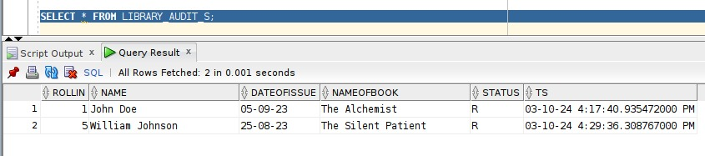

Library Audit Table After Updating